Inheritance

Workshop #6

Flutter Developer Bootcamp

# **Purpose**

This workshop demonstrates the class inheritance and how properties are inherited and accessed through subclass instances.

**Problem**

In the given workshop demonstrates the class inheritance and property access. It defines three classes: cs, cs1, and cs2.

* Class cs inherits from cs1 and introduces its own property cs_String.
* Class cs1 inherits from cs2 and adds its own property str.
* Class cs2 defines the property str1.

In the main function, an instance of cs is created (obj), demonstrating how properties from all three classes (cs_String, str, and str1) are accessed and printed. This example highlights Dart's support for hierarchical class structures and property inheritance, essential for organizing and reusing code effectively in object-oriented programming. You need to solve the error in the given code.

**How to Solve**

1. Checkout the workshop from Git Repo:

git clone -b <user-branch> <repo-URL>

1. Open the root folder inside VS Code
2. Open the root folder in terminal
3. Run the command dart run filename.dart
4. Class Definitions:

* cs inherits from cs1 and introduces cs_String.
* cs1 inherits from cs2 and adds str.
* cs2 defines str1.

1. Error Resolution:

* Ensure proper hierarchical inheritance (cs from cs1, cs1 from cs2).
* Correct property definitions in each class (cs_String, str, str1).

1. Main Function Execution:

* Creates an instance obj of cs.
* Accesses properties cs_String, str, and str1 from obj.

1. Go To File: <specific-file--method> à <method-name>, implement your logic.

**You will Achieve**

When you complete this workshop you will learn the following:

**Achievements:**

* **Understanding Class Inheritance:**
* Learn how classes (cs, cs1, cs2) can inherit properties and behaviors from parent classes, creating a hierarchical structure.
* **Property Access:**
* Explore how properties (cs_String, str, str1) defined in different levels of the class hierarchy can be accessed and utilized.
* **Error Resolution:**
* Address any potential issues related to class inheritance, ensuring proper definition and access of properties.

**Components:**

* **Class Definitions:**
* cs: Inherits from cs1 and introduces cs_String.
* cs1: Inherits from cs2 and adds str.
* cs2: Defines str1.
* **Main Function:**
* Creates an instance (obj) of cs.
* Accesses and prints cs_String, str, and str1 properties from obj.

# **Screenshots**

## **Before implementation (without solving error)**

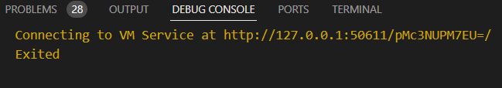

## **After implementation (solving error)**

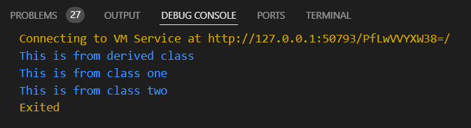

# **How to submit your workshop**

Push your project back to the same git branch using command:

<command name>

# **Happy Coding!**